Operating System Practical

University Of Delhi


Ramanujan College
DSC 08: Operating System
Semester-3
(2024-25)

Submitted To:
~Ms. Sheetal Singh
(Assistant Professor)
Department of Computer Science
(

Submitted By:
~Ratnesh Kumar
20231432(23020570034)

Acknowledgement
I would like to take this opportunity to acknowledge everyone who has helped us in every stage of this project.
I am deeply indebted to my Operating System Professor, Ms. Sheetal Singh for his guidance and suggestions in completing this project. The completion of this project was possible under his guidance and support.
I am also very thankful to my parents and my friends who have boosted me up morally with their continuous support.
At last but not least, I am very thankful to God almighty for showering his blessings upon me.

S.no | Topic | Remarks
1. | Execute various LINUX commands for:  i. Information Maintenance: wc, clear, cal, who, date, pwd  ii. File Management: cat, cp, rm, mv, cmp, comm, diff, find, grep, awk  iii. Directory Management: cd, mkdir, rmdir, ls
2. | Execute various LINUX commands for:  i. Process Control: fork, getpid, ps, kill, sleep  ii. Communication: Input-output redirection, Pipe  iii. Protection Management: chmod, chown, chgrp
3. | Write a program (using fork () and/or exec () commands) where parent and child execute:  i. same program, same code.  ii. same program, different code.  iii. before terminating, the parent waits for the child to finish its task.
4. | Write a program to report behaviour of Linux kernel including kernel version, CPU type and CPU  information.
5. | Write a program to report behaviour of Linux kernel including information on configured memory, amount of  free and used memory
6. | Write a program to copy files using system calls.
7. | Write a program to implement FCFS scheduling algorithm.
8. | Write a program to implement SJF scheduling algorithm.
9. | Write a program to implement non-preemptive priority-based scheduling algorithm.
10. | Write a program to implement SRTF scheduling algorithm.
11. | Write a program to calculate sum of n numbers using Pthreads. A list of n numbers is divided into two smaller  list of equal size, two separate threads are used to sum the sub lists.
12. | Write a program to implement first-fit, best-fit and worst-fit allocation strategies.
Index
1. Execute various LINUX commands for:
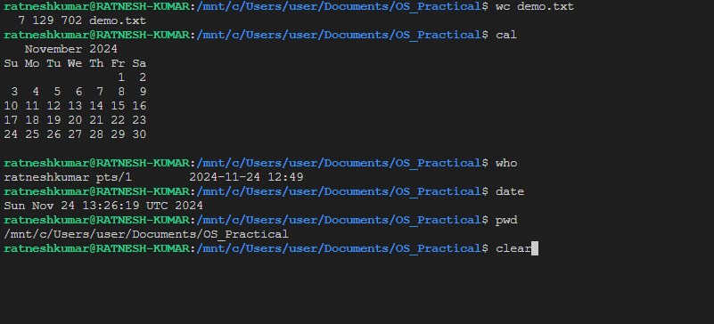
i. Information Maintenance: wc, clear, cal, who, date, pwd
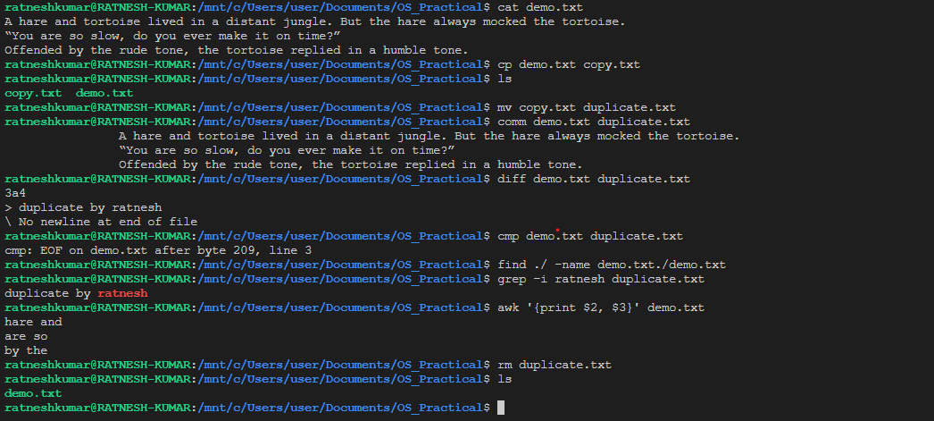
ii. File Management: cat, cp, rm, mv, cmp, comm, diff, find, grep, awk
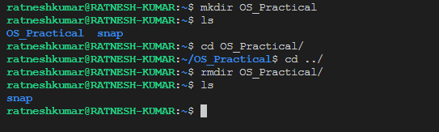
iii. Directory Management: cd, mkdir, rmdir, ls

2. Execute various LINUX commands for:
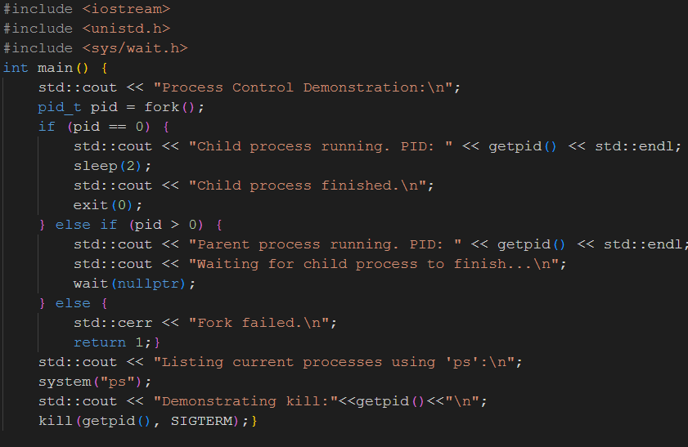
i. Process Control: fork, getpid, ps, kill, sleep
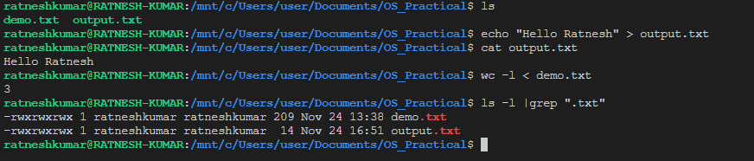
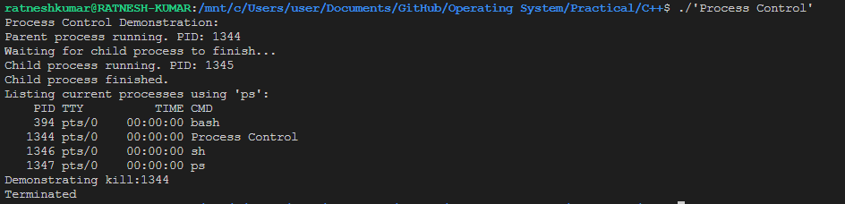
ii. Communication: Input-output redirection, Pipe
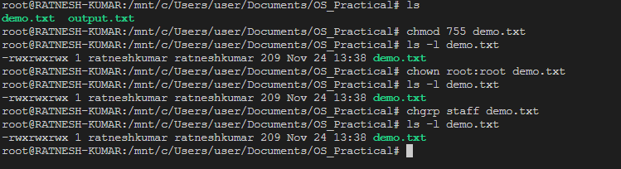
iii. Protection Management: chmod, chown, chgrp

3. Write a program (using fork () and/or exec () commands) where parent and child execute:
i. same program, same code.
ii. same program, different code.
iii. before terminating, the parent waits for the child to finish its task.
Code:-
#include <iostream>
#include <unistd.h>
#include <sys/wait.h>
using namespace std;
void execute_same_program_same_code() {
cout << "Executing the same program with same code.\n";}
void execute_same_program_different_code() {
cout << "Parent is executing its task.\n";
execlp("pwd", "pwd",nullptr);
perror("exec failed");}
int main() {
pid_t pid = fork();
if (pid == -1) {
cerr << "Fork failed!\n";
return 1;}
if (pid == 0) {
cout << "Child process (PID: " << getpid() << ") started.\n";
execute_same_program_same_code();
execute_same_program_different_code();
} else {
cout << "Parent process (PID: " << getpid() << ") started.\n";
execute_same_program_same_code();
cout << "Parent is waiting for child to finish...\n";
wait(NULL);
cout << "Child has finished. Parent is now terminating.\n";}
return 0;}
Output:-
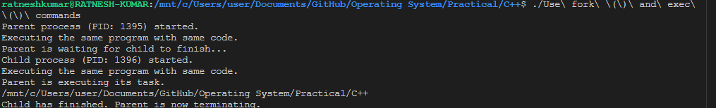
4. Write a program to report behaviour of Linux kernel including kernel version, CPU type and CPU information.
Code:-
#include <stdio.h>
#include <stdlib.h>
#include <unistd.h>
int main() {
printf("Kernel Version:\n");
system("uname -r");
printf("\nCPU Type:\n");
system("uname -m");
printf("\nDetailed CPU Information:\n");
system("lscpu");
return 0;}
Output:-
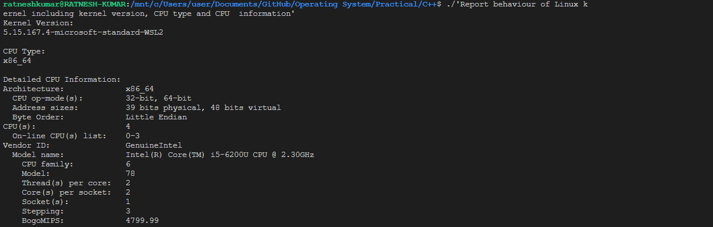
5. Write a program to report behaviour of Linux kernel including information on configured memory, amount of free and used memory. (Memory information)
Code:-
#include <iostream>
#include <fstream>
#include <string>
using namespace std;
void get_memory_info() {
ifstream meminfo("/proc/meminfo");
string line;
if (!meminfo.is_open()) {
cerr << "Failed to open /proc/meminfo" << endl;
exit(1);}
cout << "\nMemory Information:\n";
while (getline(meminfo, line)) {
if (line.find("MemTotal") != string::npos) {
cout << line << endl;}
if (line.find("MemFree") != string::npos) {
cout << line << endl; }
if (line.find("MemAvailable") != string::npos) {
cout << line << endl;}
if (line.find("Buffers") != string::npos) {
cout << line << endl; }
if (line.find("Cached") != string::npos) {
cout << line << endl;}
if (line.find("SwapTotal") != string::npos) {
cout << line << endl; }
if (line.find("SwapFree") != string::npos) {
cout << line << endl;}}
meminfo.close();}
int main() {
cout << "Linux Kernel Memory Information:\n";
get_memory_info();
return 0;}
Output:- 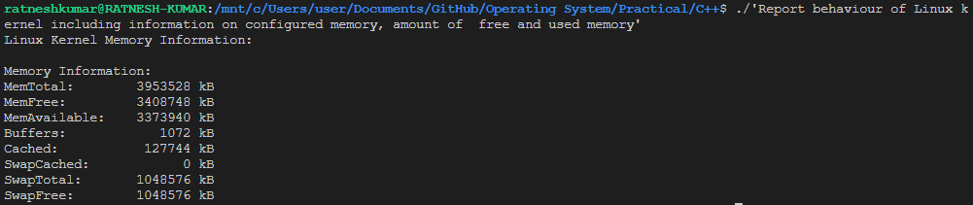

6. Write a program to copy files using system calls.
Code:-
#include <iostream>
#include <fcntl.h>
#include <unistd.h>
#include <sys/types.h>
#include <sys/stat.h>
using namespace std;
void copy_file(const char* source, const char* destination) {
int source_fd = open(source, O_RDONLY);
if (source_fd == -1) {
perror("Failed to open source file");
exit(1);}
int dest_fd = open(destination, O_WRONLY | O_CREAT | O_TRUNC, S_IRUSR | S_IWUSR);
if (dest_fd == -1) {
perror("Failed to open destination file");
close(source_fd);
exit(1);}
char buffer[1024];
ssize_t bytes_read, bytes_written;
while ((bytes_read = read(source_fd, buffer, sizeof(buffer))) > 0) {
bytes_written = write(dest_fd, buffer, bytes_read);
if (bytes_written != bytes_read) {
perror("Error writing to destination file");
close(source_fd);
close(dest_fd);
exit(1);}}
if (bytes_read == -1) {
perror("Error reading from source file");}
close(source_fd);
close(dest_fd);
cout << "File copied successfully from " << source << " to " << destination << endl;}
int main() {
const char* source = "source.txt";
const char* destination = "destination.txt";
copy_file(source, destination);
return 0;}
Output:-
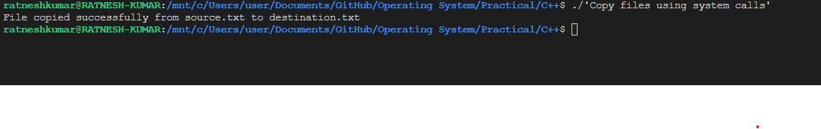
7. Write a program to implement FCFS scheduling algorithm.
Code:-
#include <iostream>
void First_Come_First_Serve(std::string name_of_process[], int burst_time[],int number_of_processes){
double waiting_time = 0;
double turnaround_time = 0;
double total_waiting_time = 0;
double total_turnaround_time = 0;
std::cout<<"Name Of Process\tBurst Time\tWaiting Time\tTurnAround Time"<<std::endl;
for (int i=0;i<number_of_processes;i++){
turnaround_time += burst_time[i];
total_turnaround_time+=turnaround_time;
std::cout<<name_of_process[i]<<"\t\t"<<burst_time[i]<<"\t\t"<<waiting_time<<"\t\t"<<turnaround_time<<std::endl;
total_waiting_time+=waiting_time;
waiting_time += burst_time[i];}
std::cout<<"\nAverage Waiting Time is:: "<<total_waiting_time/number_of_processes<<"\nAverage TurnAround Time is::"<<total_turnaround_time/number_of_processes<<std::endl;}
int main(){
int number_of_processes;
std::cout<<"Enter the number of processes: ";
std::cin>>number_of_processes;
std::string name_of_process[number_of_processes];
int burst_time[number_of_processes];
for (int i=0;i<number_of_processes;i++){
std::cout<<"Enter Name of Process:: ";
std::cin>>name_of_process[i];
std::cout<<"Enter Burst Time of Process "<<name_of_process[i]<<":: ";
std::cin>>burst_time[i];}
First_Come_First_Serve(name_of_process,burst_time,number_of_processes);}
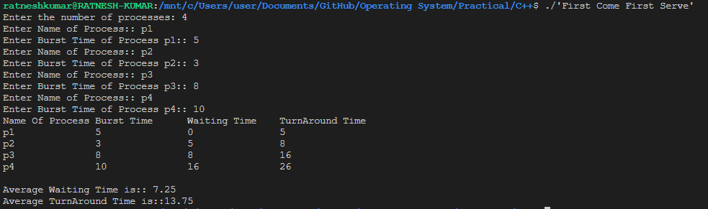
Output:-

8. Write a program to implement SJF scheduling algorithm.
Code:-
#include <iostream>
void First_Come_First_Serve(std::string name_of_process[], int burst_time[],int number_of_processes){
double waiting_time = 0;
double turnaround_time = 0;
double total_waiting_time = 0;
double total_turnaround_time = 0;
std::cout<<"Name Of Process\tBurst Time\tWaiting Time\tTurnAround Time"<<std::endl;
for (int i=0;i<number_of_processes;i++){
turnaround_time += burst_time[i];
total_turnaround_time+=turnaround_time;
std::cout<<name_of_process[i]<<"\t\t"<<burst_time[i]<<"\t\t"<<waiting_time<<"\t\t"<<turnaround_time<<std::endl;
total_waiting_time+=waiting_time;
waiting_time += burst_time[i];}
std::cout<<"\nAverage Waiting Time is:: "<<total_waiting_time/number_of_processes<<"\nAverage TurnAround Time is::"<<total_turnaround_time/number_of_processes<<std::endl;}
void Sort(std::string name_of_process[], int burst_time[],int number_of_processes){
for(int i=0;i<number_of_processes;i++){
for(int j=0;j<number_of_processes;j++){
if (burst_time[i] < burst_time[j]){
int temp_burst = burst_time[i];
burst_time[i] = burst_time[j];
burst_time[j] = temp_burst;
std::string temp_name_of_process = name_of_process[i];
name_of_process[i] = name_of_process[j];
name_of_process[j]= temp_name_of_process;}}}
First_Come_First_Serve(name_of_process,burst_time,number_of_processes);}
int main(){
int number_of_processes;
std::cout<<"Enter the number of processes: ";
std::cin>>number_of_processes;
std::string name_of_process[number_of_processes];
int burst_time[number_of_processes];
for (int i=0;i<number_of_processes;i++){
std::cout<<"Enter Name of Process:: ";
std::cin>>name_of_process[i];
std::cout<<"Enter Burst Time of Process "<<name_of_process[i]<<":: ";
std::cin>>burst_time[i];}
Sort(name_of_process,burst_time,number_of_processes);}
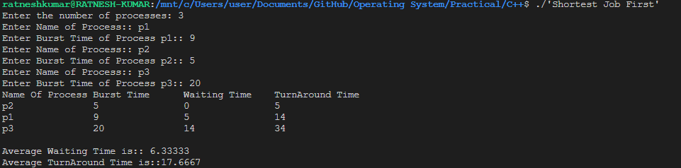
Output:-

9. Write a program to implement non-preemptive priority-based scheduling algorithm.
Code:-
#include <iostream>
void First_Come_First_Serve(std::string name_of_process[], int burst_time[],int priority[],int number_of_processes){
double waiting_time = 0;
double turnaround_time = 0;
double total_waiting_time = 0;
double total_turnaround_time = 0;
std::cout<<"Name Of Process\tBurst Time\tPriority\tWaiting Time\tTurnAround Time"<<std::endl;
for (int i=0;i<number_of_processes;i++){
turnaround_time += burst_time[i];
total_turnaround_time+=turnaround_time;
std::cout<<name_of_process[i]<<"\t\t"<<burst_time[i]<<"\t\t"<<priority[i]<<"\t\t"<<waiting_time<<"\t\t"<<turnaround_time<<std::endl;
total_waiting_time+=waiting_time;
waiting_time += burst_time[i];}
std::cout<<"\nAverage Waiting Time is:: "<<total_waiting_time/number_of_processes<<"\nAverage TurnAround Time is::"<<total_turnaround_time/number_of_processes<<std::endl;}
void Sort(std::string name_of_process[], int burst_time[],int priority[],int number_of_processes){
for(int i=0;i<number_of_processes;i++){
for(int j=0;j<number_of_processes;j++){
if (priority[i] < priority[j]){
int temp_burst = burst_time[i];
burst_time[i] = burst_time[j];
burst_time[j] = temp_burst;
int temp_priority = priority[i];
priority[i] = priority[j];
priority[j] = temp_priority;
std::string temp_name_of_process = name_of_process[i];
name_of_process[i] = name_of_process[j];
name_of_process[j]= temp_name_of_process;}}}
First_Come_First_Serve(name_of_process,burst_time,priority,number_of_processes);}
int main(){
int number_of_processes;
std::cout<<"Enter the number of processes: ";
std::cin>>number_of_processes;
std::string name_of_process[number_of_processes];
int burst_time[number_of_processes];
int priority[number_of_processes];
for (int i=0;i<number_of_processes;i++){
std::cout<<"Enter Name of Process:: ";
std::cin>>name_of_process[i];
std::cout<<"Enter Burst Time of Process "<<name_of_process[i]<<":: ";
std::cin>>burst_time[i];
std::cout<<"Enter Priority of Process "<<name_of_process[i]<<":: ";
std::cin>>priority[i];}
Sort(name_of_process,burst_time, priority,number_of_processes);}
Output:-
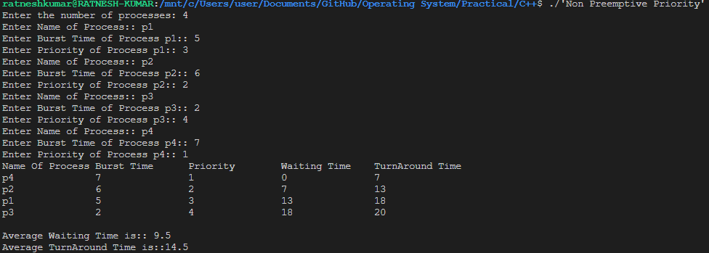
10. Write a program to implement SRTF scheduling algorithm.
Code:-
#include <iostream>
void display(std::string name_of_process[], int burst_time[], int arrival_time[],int number_of_processes,int waiting_time[],int turnaround_time[]){
double total_waiting_time = 0;
double total_turnaround_time = 0;
std::cout<<"Name Of Process\tBurst Time\tArrival Time\tWaiting Time\tTurnAround Time"<<std::endl;
for (int num=0;num<number_of_processes;num++){
total_waiting_time += waiting_time[num];
total_turnaround_time += turnaround_time[num]; std::cout<<name_of_process[num]<<"\t\t"<<burst_time[num]<<"\t\t"<<arrival_time[num]<<"\t\t"<<waiting_time[num]<<"\t\t"<<turnaround_time[num]<<std::endl;}
std::cout<<"\nAverage Waiting Time is:: "<<total_waiting_time / number_of_processes<<"\nAverage TurnAround Time is:: "<<total_turnaround_time / number_of_processes<<std::endl;}
void shortest_remaining_time_first(std::string name_of_process[], int number_of_processes, int burst_time[], int arrival_time[]){
int waiting_time[number_of_processes];
int turnaround_time[number_of_processes];
int remaining_time[number_of_processes];
std::copy(burst_time,burst_time+number_of_processes,remaining_time);
int clock = 0;
int completed = 0;
float min_burst = float('inf');
signed int shortest = -1;
bool finished = false;
while (completed != number_of_processes){
for (int num=0;num<number_of_processes;num++){
if (arrival_time[num] <= clock and remaining_time[num] < min_burst and remaining_time[num] > 0){
min_burst = remaining_time[num];
shortest = num;
finished = true;}}
if (not finished){
clock += 1;
continue;}
remaining_time[shortest] -= 1;
min_burst = remaining_time[shortest];
if (min_burst == 0){
min_burst = float('inf');}
if (remaining_time[shortest] == 0){
completed += 1;
finished = false;
int finish_time = clock + 1;
waiting_time[shortest] = finish_time - burst_time[shortest] - arrival_time[shortest];
turnaround_time[shortest] = finish_time - arrival_time[shortest];}
if (waiting_time[shortest] < 0){
waiting_time[shortest] = 0;}
clock += 1;}
display(name_of_process, burst_time, arrival_time, number_of_processes,waiting_time,turnaround_time);}
int main(){
int number_of_processes;
std::cout<<"Enter the number of processes: ";
std::cin>>number_of_processes;
std::string name_of_process[number_of_processes];
int burst_time[number_of_processes];
int arrival_time[number_of_processes];
for (int i=0;i<number_of_processes;i++){
std::cout<<"Enter Name of Process:: ";
std::cin>>name_of_process[i];
std::cout<<"Enter Burst Time of Process "<<name_of_process[i]<<":: ";
std::cin>>burst_time[i];
std::cout<<"Enter Arrival Time of Process "<<name_of_process[i]<<":: ";
std::cin>>arrival_time[i];}
shortest_remaining_time_first(name_of_process, number_of_processes, burst_time,arrival_time);}
Output:-

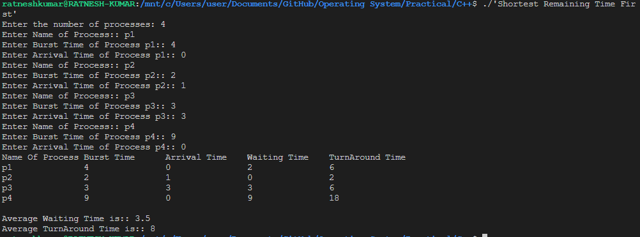

11. Write a program to calculate sum of n numbers using Pthreads. A list of n numbers is divided into two smaller list of equal size, two separate threads are used to sum the sub lists.
Code:-
#include <pthread.h>
#include <iostream>
#include <vector>
using namespace std;
struct ThreadData {
vector<int>& arr;
int start;
int end;
int sum;};
void* calculate_sum(void* arg) {
ThreadData* data = static_cast<ThreadData*>(arg);
data->sum = 0;
for (int i = data->start; i < data->end; ++i) {
data->sum += data->arr[i];}
pthread_exit(nullptr);}
int main() {
int n;
cout << "Enter the number of elements: ";
cin >> n;
vector<int> arr(n);
cout << "Enter " << n << " elements: " << endl;
for (int i = 0; i < n; ++i) {
cin >> arr[i];}
int mid = n / 2;
ThreadData data1 = {arr, 0, mid, 0};
ThreadData data2 = {arr, mid, n, 0};
pthread_t thread1, thread2;
pthread_create(&thread1, nullptr, calculate_sum, static_cast<void*>(&data1));
pthread_create(&thread2, nullptr, calculate_sum, static_cast<void*>(&data2));
pthread_join(thread1, nullptr);
pthread_join(thread2, nullptr);
int total_sum = data1.sum + data2.sum;
cout << "The sum of the numbers is: " << total_sum << endl;
return 0;}
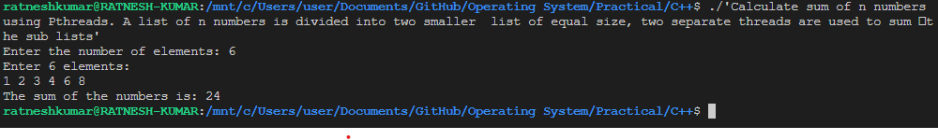
Output:-
12. Write a program to implement first-fit, best-fit and worst-fit allocation strategies.
Code:-
#include <iostream>
#include <vector>
#include <string>
#include <sstream>
using namespace std;
void display(const vector<pair<string, int>>& memory) {
int count = 1;
cout << "Memory Status:" << endl;
for (const auto& frame : memory) {
cout << "Frame: " << count << " | Process: " << frame.first << " | Size: " << frame.second << endl;
count++;}}
void firstFit(int noOfFrames, vector<pair<string, int>>& memory, const pair<string, int>& process) {
bool flag = false;
for (int i = 0; i < noOfFrames; i++) {
if (memory[i].first == "free" && memory[i].second >= process.second) {
memory[i].first = process.first;
display(memory);
flag = true;
break;}}
if (!flag) {
cout << "\nYou Have Not Enough Space To Run New Process" << endl;}}
void bestFit(int noOfFrames, vector<pair<string, int>>& memory, const pair<string, int>& process) {
int flag = -1;
for (int i = 0; i < noOfFrames; i++) {
if (memory[i].first == "free" && memory[i].second >= process.second) {
if (flag == -1 || memory[i].second < memory[flag].second) {
flag = i;}}}
if (flag != -1) {
memory[flag].first = process.first;
display(memory);
} else {
cout << "\nYou do not have enough space to run the new process." << endl;}}
void worstFit(int noOfFrames, vector<pair<string, int>>& memory, const pair<string, int>& process) {
int flag = -1;
for (int i = 0; i < noOfFrames; i++) {
if (memory[i].first == "free" && memory[i].second >= process.second) {
if (flag == -1 || memory[i].second > memory[flag].second) {
flag = i;}}}
if (flag != -1) {
memory[flag].first = process.first;
display(memory);
} else {
cout << "\nYou do not have enough space to run the new process." << endl;}}
int main() {
vector<pair<string, int>> memory;
while (true) {
cout << "Enter memory type (used/free) and value, or 'q' to quit: ";
string input;
getline(cin, input);
if (input == "q") {
break;}
istringstream iss(input);
string memoryType;
int value;
iss >> memoryType >> value;
memory.push_back({memoryType, value});}
cout << "Enter process name and value: ";
string processName, processValue;
cin >> processName >> processValue;
int processValueInt = stoi(processValue);
pair<string, int> process = {processName, processValueInt};
cout << "Main Menu \n1. First Fit\n2. Best Fit\n3. Worst Fit\nEnter your Choice:: ";
int choice;
cin >> choice;
if (choice == 1) {
firstFit(memory.size(), memory, process);
} else if (choice == 2) {
bestFit(memory.size(), memory, process);
} else {
worstFit(memory.size(), memory, process);}
return 0;}
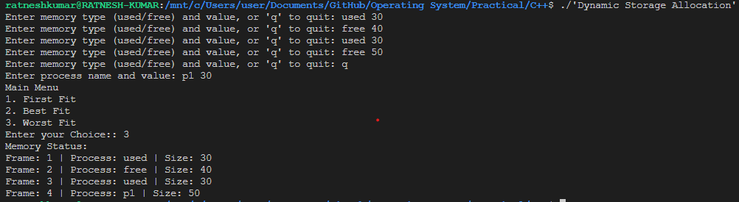
Output:-

